TechNova Fest 2026 Website

1. Introduction
The TechNova Fest 2026 Website is a college festival website developed using HTML and CSS. It provides information about college events, event schedules, festival activities, registration, and contact details.
The main purpose of this website is to help students explore different technical and cultural events and register to participate in the college festival.
Website title: TechNova Fest 2026
Tagline: Learn | Compete | Celebrate
Technologies used:
- HTML5: Creates the structure and content of the website.
- CSS3: Adds colors, layouts, backgrounds, spacing, animations, and responsive design.
- Emoji and external images: Make the website attractive and visually appealing.

2. Explanation of the Code
The code is divided into two main parts: HTML and CSS. HTML defines the content, while CSS controls how that content appears on the screen.
Pasted text(6).txt
A. HTML Code Explaination
HTML element | Explanation
<html> | Defines the HTML document.
<head> | Contains page settings and the website title.
<title> | Sets the browser tab title to TechNova Fest 2026.
<body> | Contains all visible website content.
<header> | Displays the website logo, navigation links, and registration button.
<nav> | Provides links to different sections.
<section> | Organizes the page into separate content areas.
<div> | Groups related elements together.
<h1>, <h2>, <h3> | Display headings at different levels.
<p> | Displays paragraphs and descriptions.
<a> | Creates clickable links.
<table> | Displays the festival schedule in rows and columns.
<form> | Contains the student registration fields.
<input> | Accepts the student's name, roll number, and email.
<select> | Allows students to choose a department and event.
<button> | Provides the registration submission control.
<footer> | Displays copyright and additional website information.
B. CSS Code Explanation
The CSS code styles the website and makes it look professional.
- Universal selector (*): Removes default margins and padding and applies a common font.
- Background and text colors: Use dark navy, white, pink, purple, and blue for a modern festival theme.
- Flexbox: Arranges the header, navigation, and footer content.
- CSS Grid: Organizes event cards, schedule/about sections, registration fields, and contact details.
- Linear gradients: Create colorful buttons, event backgrounds, and decorative panels.
- Border radius: Gives cards, buttons, and panels rounded corners.
- Box shadow: Adds depth to event cards.
- Hover effects: Move event cards slightly upward when the mouse pointer is placed over them.
- Media queries: Adjust the layout for tablets and mobile phones.
Pasted text(6).txt
Pasted text(6).txt

3. Features of the Website
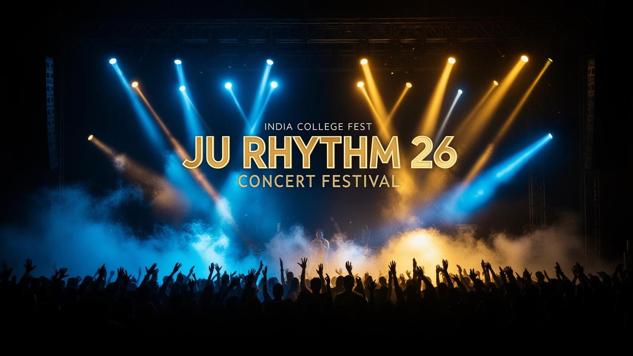
1. Navigation Bar
Displays the TechNova Fest logo and links to Home, Events, Schedule, About, Registration, and Contact. The Register Now button takes users directly to the registration section.
2. Featured Events
Displays six events: Code Sprint, Art Attack, Singing Star, Gaming Zone, Business Quiz, and Rangoli. Each card includes an icon, description, and technical or cultural category.
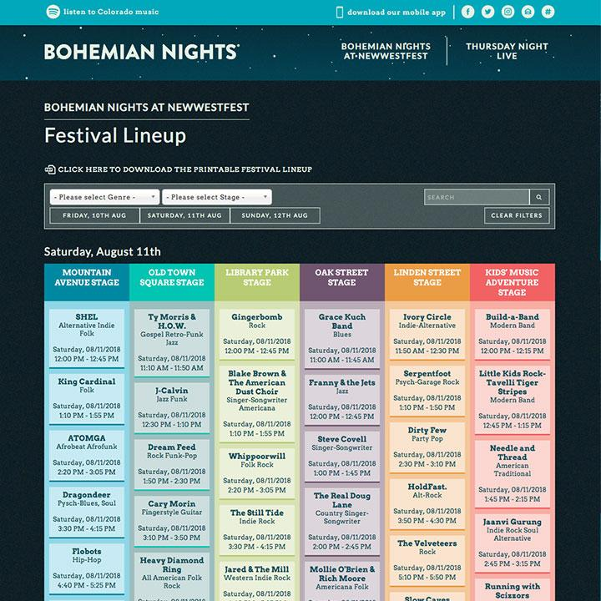
3. Event Schedule
Uses an HTML table to display activities scheduled for 15, 16, and 17 March 2026.
4. About the Fest
Explains the purpose of the festival and displays highlights such as events, participants, prizes, and friendship.
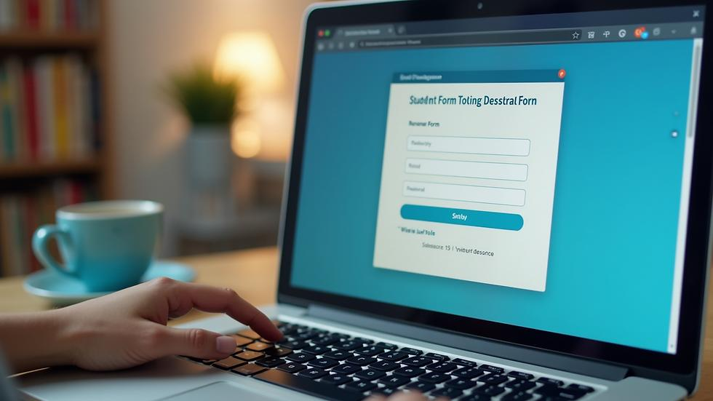
5. Student Registration Form
Collects the student's full name, roll number, email address, department, and preferred event. HTML required fields and email input validation help users enter information correctly.
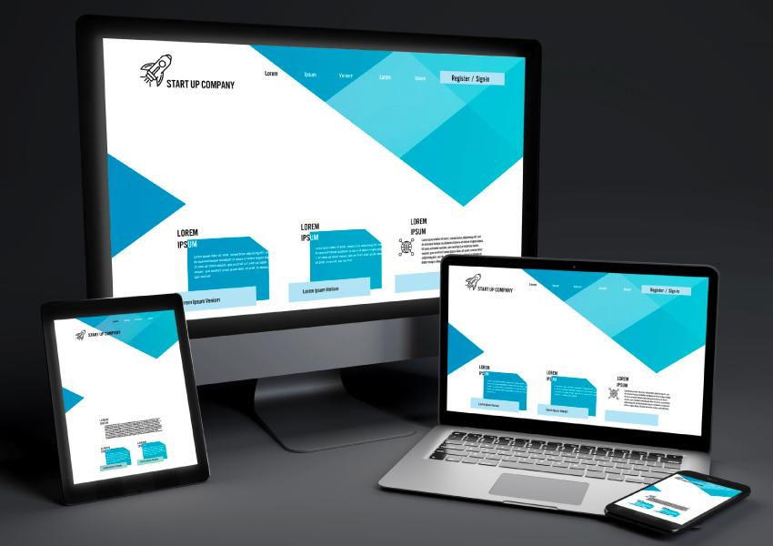
6. Responsive Design
Media queries adjust the layout for different screen sizes. Event cards change from six columns to three, two, or one column as the screen becomes smaller.
Other features include smooth scrolling, colorful gradient buttons, rounded cards, mouse-hover effects, contact information, and a footer with copyright details.
Pasted text(6).txt
Pasted text(6).txt
Pasted text(6).txt

4. Development of the Website
The website can be developed through the following steps.
- Step 1: Requirement analysis
Identify the purpose of the website and the information students need, such as events, schedules, registration, and contact details.
- Step 2: HTML structure
Create the HTML document and add the header, navigation bar, hero section, event cards, schedule table, About section, registration form, contact section, and footer.
- Step 3: CSS styling
Apply colors, fonts, spacing, backgrounds, gradients, borders, shadows, and rounded corners to improve the website's appearance.
- Step 4: Layout design
Use Flexbox for alignment and CSS Grid to arrange the event cards, schedule, registration fields, and contact information.
- Step 5: Add images and visual elements
Add festival background images, emoji icons, event illustrations, and decorative elements.
- Step 6: Add navigation and form controls
Connect navigation links to section IDs and create registration inputs, dropdown menus, and a submit button.
- Step 7: Responsive design
Use media queries at different screen widths to make the website suitable for desktops, tablets, and mobile phones.
- Step 8: Testing
Open the HTML file in a browser and check the links, layout, text, form validation, images, and appearance at different screen sizes.

5. Website Sections and Their Purpose
Section | Purpose
Home | Introduces TechNova Fest 2026.
Events | Shows the available technical and cultural competitions.
Schedule | Displays the activities planned for each festival day.
About | Describes the festival and highlights its benefits.
Registration | Allows students to enter their details and select an event.
Contact | Displays email, campus location, and phone number.
Footer | Displays navigation information and copyright details.

6. Advantages of the Website
- Provides festival information in one place.
- Makes it easy for students to explore events.
- Offers a simple and attractive interface.
- Helps students view the festival schedule.
- Provides a registration form with basic browser validation.
- Supports different screen sizes.
- Demonstrates practical use of HTML and CSS.

7. Limitations and Future Enhancements
The current website is a front-end demonstration. The HTML form does not save registration information to a database or send it to a server. There is also no JavaScript-based registration confirmation or event-management system.
Pasted text(6).txt
Future enhancements could include:
- JavaScript: Display success messages and provide additional validation.
- Python with Flask or Django: Build a backend to process registrations.
- Database: Store student details and selected events.
- Admin dashboard: Manage participants, schedules, and results.
- Email notifications: Send registration confirmations.
- Live event updates: Publish schedule changes and announcements.

8. Conclusion
The TechNova Fest 2026 website is a college festival information and registration website developed using HTML5 and CSS3. It combines an attractive design with event cards, a schedule table, festival information, a registration form, and contact details. The project demonstrates important web development concepts, including semantic HTML elements, CSS Grid, Flexbox, gradients, hover effects, and responsive design.
It can serve as a beginner-level web development project and can be expanded into a complete festival management system by adding JavaScript, a backend, and a database.

9.output
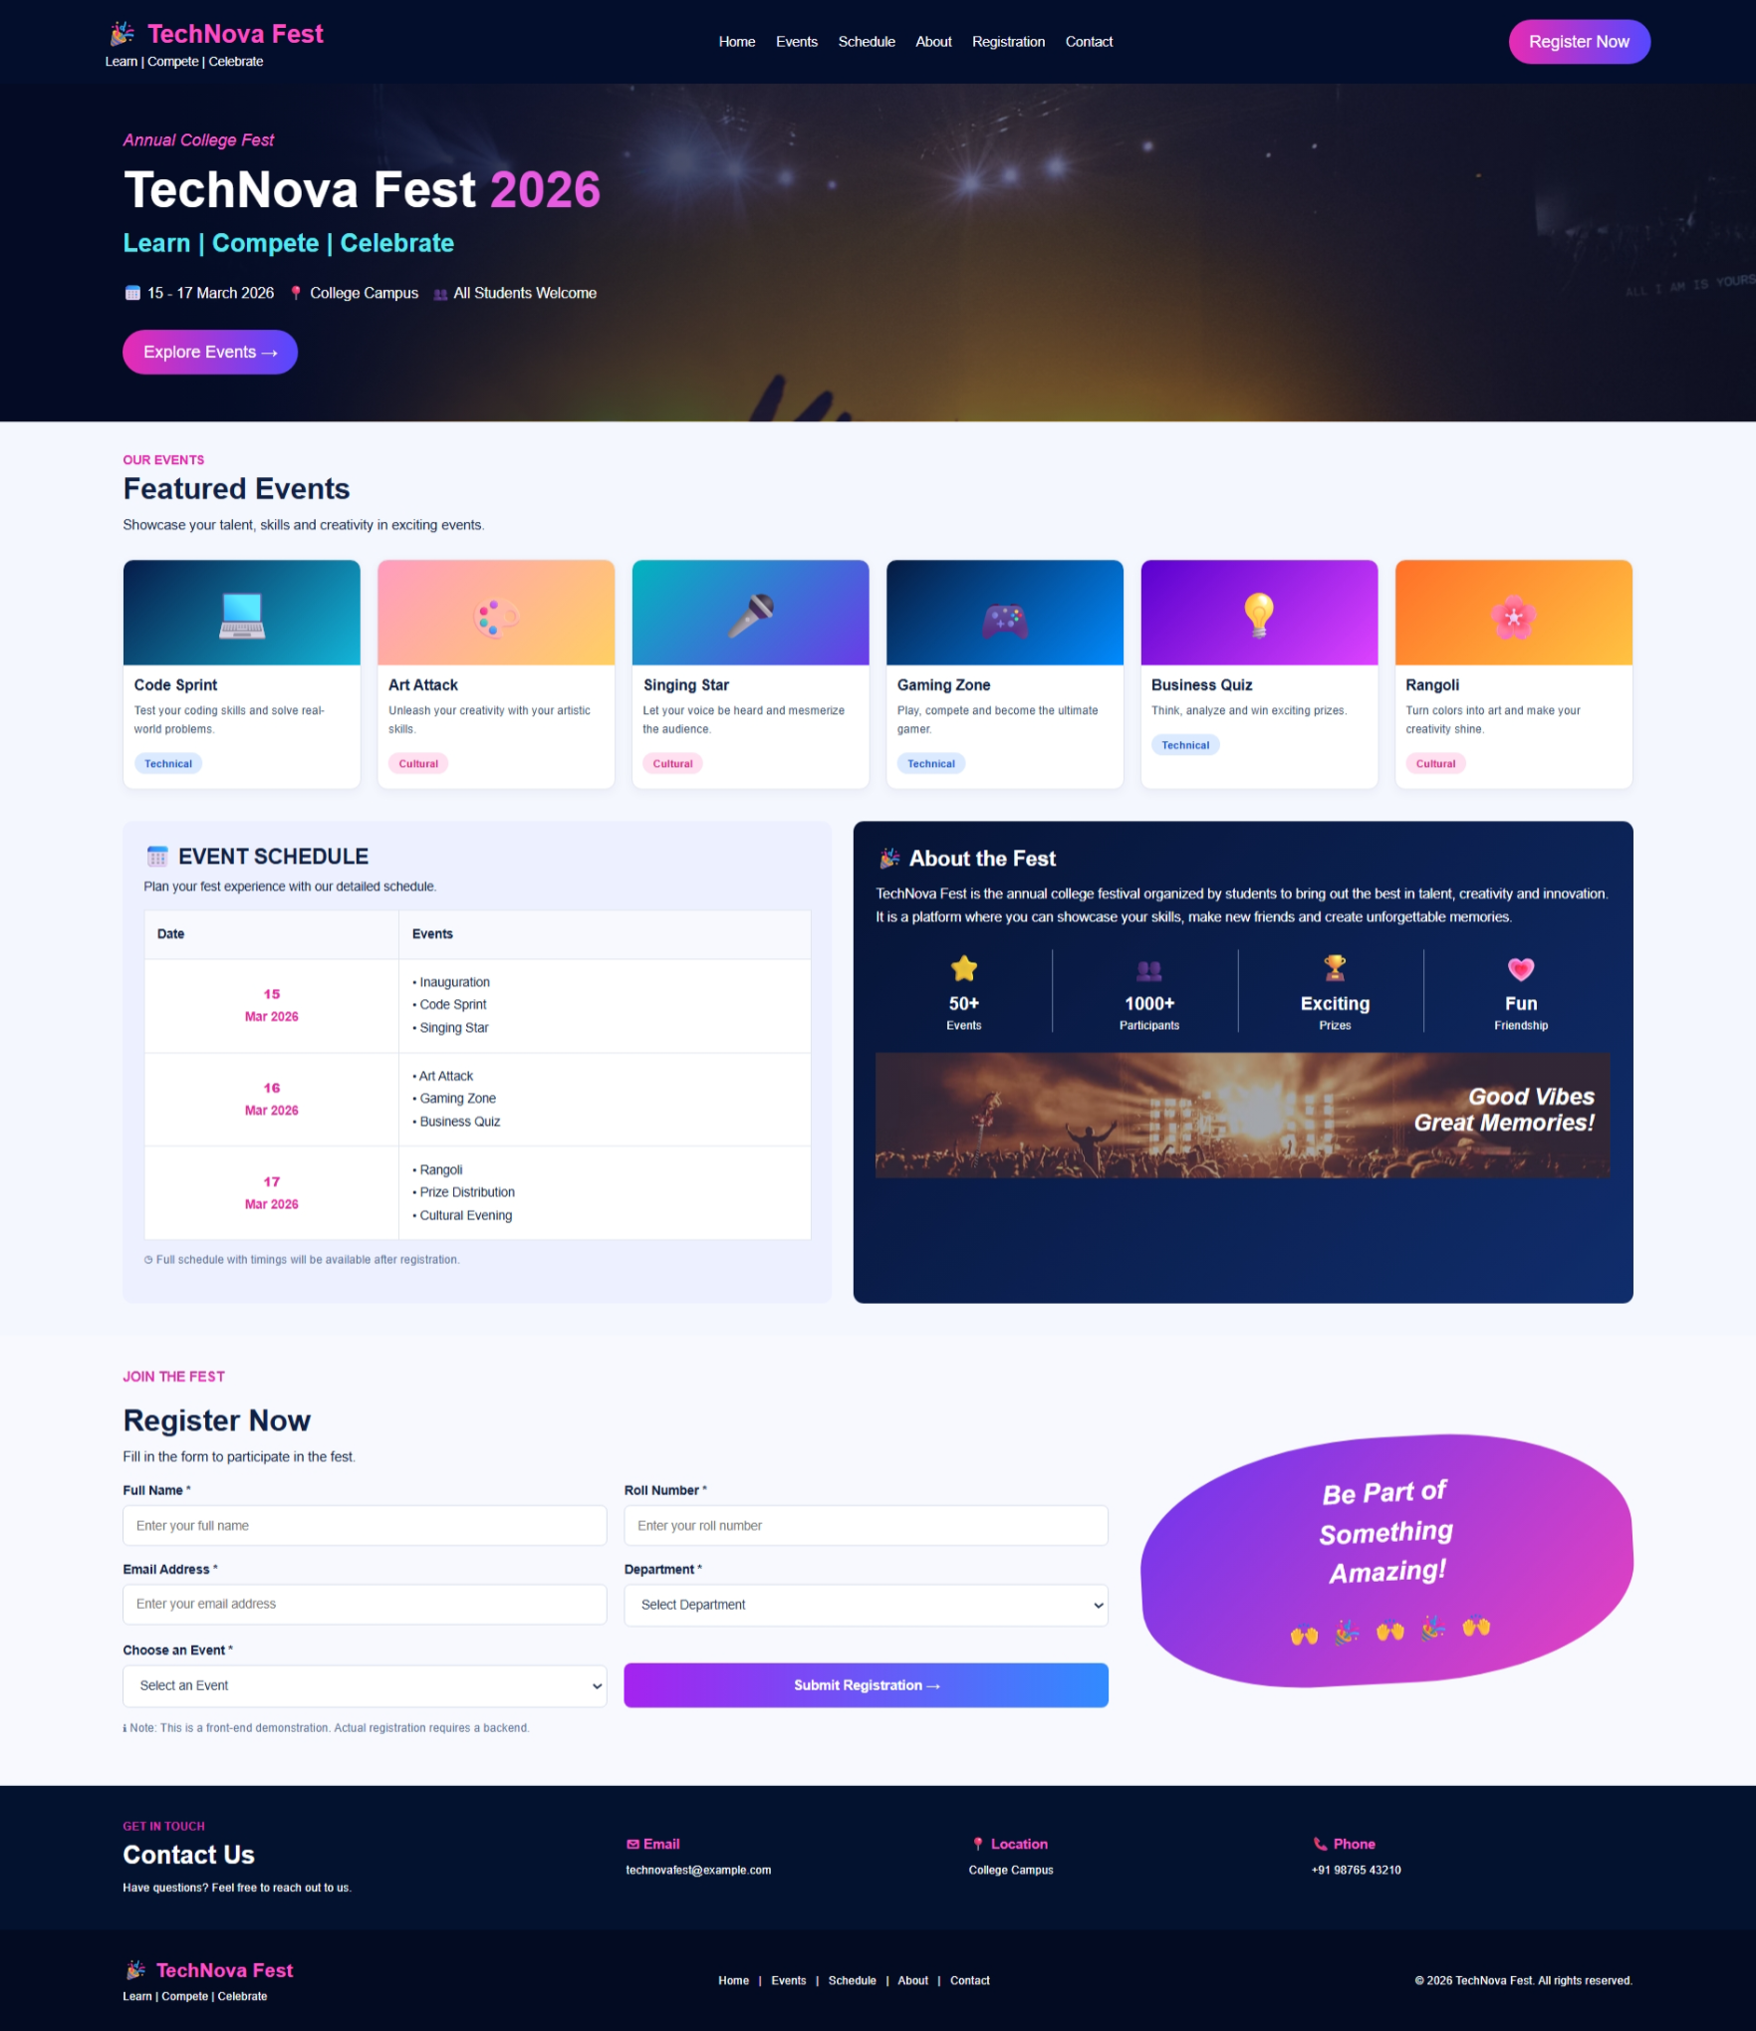

10.code
<!DOCTYPE html>
<html lang="en">
<head>
<meta charset="UTF-8">
<meta name="viewport" content="width=device-width, initial-scale=1.0">
<title>TechNova Fest 2026</title>
</head>
<style>

* {
margin: 0;
padding: 0;
box-sizing: border-box;
font-family: Arial, sans-serif;
scroll-behavior: smooth;
}

body {
background: #f5f7ff;
color: #102044;
}

/* Navigation */
header {
background: #030e2d;
color: white;
padding: 15px 6%;
display: flex;
justify-content: space-between;
align-items: center;
flex-wrap: wrap;
gap: 15px;
}

.logo h2 {
color: #ff4bc1;
}

.logo p {
font-size: 12px;
margin-top: 5px;
}

nav {
display: flex;
gap: 20px;
flex-wrap: wrap;
}

nav a {
color: white;
text-decoration: none;
font-size: 13px;
}

nav a:hover {
color: #ff4bc1;
}

.register-btn,
.explore-btn {
background: linear-gradient(90deg, #e72bb4, #5548ff);
color: white;
padding: 12px 20px;
border-radius: 25px;
text-decoration: none;
display: inline-block;
}

/* Hero Section */
.hero {
min-height: 300px;
padding: 45px 7%;
color: white;
display: flex;
align-items: center;
background:
linear-gradient(90deg, #030b25 10%, #10144799 55%, #050b2999),
url("https://images.unsplash.com/photo-1459749411175-04bf5292ceea?auto=format&fit=crop&w=1600&q=80");
background-size: cover;
background-position: center;
}

.tagline {
color: #ff58d0;
font-style: italic;
margin-bottom: 10px;
}

.hero h1 {
font-size: clamp(30px, 5vw, 48px);
margin-bottom: 10px;
}

.hero h1 span {
color: #e65bdf;
}

.hero h2 {
color: #55e7f0;
margin-bottom: 22px;
}

.hero-content > p:not(.tagline) {
margin-bottom: 22px;
line-height: 1.8;
font-size: 14px;
}

/* Common Sections */
.section {
padding: 30px 7%;
}

.small-title {
color: #df2cae;
font-size: 12px;
font-weight: bold;
margin-bottom: 5px;
}

.events > h2,
.form-section > h2 {
font-size: 28px;
margin-bottom: 8px;
}

.events > p:not(.small-title),
.form-section > p {
font-size: 13px;
line-height: 1.6;
}

/* Event Cards */
.event-container {
display: grid;
grid-template-columns: repeat(6, minmax(0, 1fr));
gap: 15px;
margin-top: 22px;
}

.event-card {
background: white;
border-radius: 10px;
overflow: hidden;
border: 1px solid #e1e5f0;
padding-bottom: 14px;
box-shadow: 0 3px 10px #14224a0b;
transition: transform 0.3s;
}

.event-card:hover {
transform: translateY(-5px);
}

.event-image {
height: 100px;
display: flex;
justify-content: center;
align-items: center;
font-size: 45px;
}

.code {
background: linear-gradient(135deg, #061b49, #13b5d9);
}

.art {
background: linear-gradient(135deg, #ff9cbf, #ffcf63);
}

.singing {
background: linear-gradient(135deg, #00b5be, #6b3be9);
}

.gaming {
background: linear-gradient(135deg, #061a40, #008bff);
}

.quiz {
background: linear-gradient(135deg, #5800ce, #dd43ff);
}

.rangoli {
background: linear-gradient(135deg, #ff7028, #ffc342);
}

.event-card h3 {
font-size: 14px;
margin: 12px 10px 8px;
}

.event-card p {
font-size: 11px;
line-height: 1.6;
margin: 0 10px 12px;
color: #435575;
}

.technical,
.cultural {
display: inline-block;
margin-left: 10px;
padding: 5px 10px;
border-radius: 15px;
font-size: 10px;
font-weight: bold;
}

.technical {
color: #1450c9;
background: #dceaff;
}

.cultural {
color: #d52283;
background: #ffe0f0;
}

/* Schedule and About */
.details {
display: grid;
grid-template-columns: 1fr 1.1fr;
gap: 20px;
padding: 0 7% 30px;
}

.schedule-box,
.about-box {
border-radius: 10px;
overflow: hidden;
}

.schedule-box {
background: #edf0ff;
padding: 20px;
}

.schedule-box h2,
.about-box h2 {
font-size: 20px;
margin-bottom: 10px;
}

.schedule-box > p {
font-size: 12px;
margin-bottom: 15px;
}

table {
width: 100%;
border-collapse: collapse;
background: white;
font-size: 12px;
}

th,
td {
border: 1px solid #e0e5f0;
padding: 12px;
text-align: left;
line-height: 1.8;
}

th {
background: #f8f9ff;
}

td:first-child {
text-align: center;
color: #e42a9f;
font-weight: bold;
}

.note {
color: #60739a;
font-size: 11px !important;
margin-top: 12px;
}

/* About */
.about-box {
background: linear-gradient(135deg, #061334, #102d6c);
color: white;
padding: 22px;
}

.about-box > p {
font-size: 13px;
line-height: 1.7;
}

.stats {
display: grid;
grid-template-columns: repeat(4, 1fr);
text-align: center;
margin: 20px 0;
gap: 8px;
}

.stats > div {
border-right: 1px solid #6a7da5;
}

.stats > div:last-child {
border-right: none;
}

.stats h2 {
font-size: 25px;
}

.stats h3 {
font-size: 17px;
}

.stats p {
font-size: 11px;
margin-top: 4px;
}

.memory {
background:
linear-gradient(#070d3055, #070d3055),
url("https://images.unsplash.com/photo-1470229722913-7c0e2dbbafd3?auto=format&fit=crop&w=1000&q=80");
background-size: cover;
background-position: center;
padding: 30px 15px;
text-align: right;
font-size: 22px;
font-style: italic;
font-weight: bold;
color: white;
min-height: 120px;
}

/* Registration */
.registration {
display: grid;
grid-template-columns: 2fr 1fr;
gap: 30px;
align-items: center;
background: #f8f8ff;
}

.form-section > p {
margin-bottom: 15px;
}

.form-grid {
display: grid;
grid-template-columns: 1fr 1fr;
gap: 16px;
}

.form-grid label {
display: block;
font-size: 12px;
font-weight: bold;
margin-bottom: 7px;
}

input,
select {
width: 100%;
padding: 12px;
border: 1px solid #d5dced;
border-radius: 6px;
background: white;
color: #263858;
font-size: 12px;
outline: none;
}

input:focus,
select:focus {
border-color: #784bff;
}

.form-grid button {
align-self: end;
border: none;
padding: 14px;
color: white;
font-size: 13px;
font-weight: bold;
border-radius: 7px;
cursor: pointer;
background: linear-gradient(90deg, #a522ef, #318bff);
}

.form-grid button:hover {
opacity: 0.85;
}

.registration-art {
background: linear-gradient(135deg, #6b35ef, #e942bf);
padding: 35px 15px;
border-radius: 50% 40% 45% 35%;
color: white;
text-align: center;
transform: rotate(-3deg);
}

.registration-art h2 {
font-size: 25px;
font-style: italic;
line-height: 1.5;
}

.registration-art p {
margin-top: 20px;
font-size: 25px;
}

/* Contact */
.contact {
display: grid;
grid-template-columns: 1.5fr 1fr 1fr 1fr;
align-items: center;
gap: 20px;
background: #03132f;
color: white;
padding: 30px 7%;
}

.contact h2 {
margin-bottom: 8px;
}

.contact h3 {
color: #ff52c8;
font-size: 13px;
margin-bottom: 8px;
}

.contact p {
font-size: 11px;
line-height: 1.7;
}

/* Footer */
footer {
background: #020b22;
color: white;
padding: 25px 7%;
display: flex;
justify-content: space-between;
align-items: center;
gap: 15px;
flex-wrap: wrap;
}

footer h3 {
color: #ff50c8;
margin-bottom: 5px;
}

footer p {
font-size: 11px;
line-height: 1.7;
}

/* Responsive Design */
@media (max-width: 1000px) {
.event-container {
grid-template-columns: repeat(3, 1fr);
}

header {
justify-content: center;
}

.details {
grid-template-columns: 1fr 1fr;
}
}

@media (max-width: 650px) {
header {
flex-direction: column;
text-align: center;
}

nav {
justify-content: center;
gap: 12px;
}

.hero {
padding: 35px 5%;
}

.hero-content > p:not(.tagline) {
font-size: 12px;
}

.event-container {
grid-template-columns: repeat(2, 1fr);
}

.details,
.registration {
grid-template-columns: 1fr;
padding-left: 5%;
padding-right: 5%;
}

.form-grid {
grid-template-columns: 1fr;
}

.registration-art {
max-width: 300px;
margin: 10px auto;
}

.contact {
grid-template-columns: 1fr 1fr;
}

footer {
flex-direction: column;
text-align: center;
}
}

@media (max-width: 380px) {
.event-container {
grid-template-columns: 1fr;
}

.stats {
grid-template-columns: repeat(2, 1fr);
gap: 15px;
}

.stats > div {
border-right: none;
}
}

</style>
<body>

<!-- Navigation -->
<header>
<div class="logo">
<h2>🎉 TechNova Fest</h2>
<p>Learn | Compete | Celebrate</p>
</div>

<nav>
<a href="#home">Home</a>
<a href="#events">Events</a>
<a href="#schedule">Schedule</a>
<a href="#about">About</a>
<a href="#registration">Registration</a>
<a href="#contact">Contact</a>
</nav>

<a href="#registration" class="register-btn">Register Now</a>
</header>

<!-- Hero Section -->
<section class="hero" id="home">
<div class="hero-content">
<p class="tagline">Annual College Fest</p>
<h1>TechNova Fest <span>2026</span></h1>
<h2>Learn | Compete | Celebrate</h2>

<p>📅 15 - 17 March 2026
&nbsp; 📍 College Campus
&nbsp; 👥 All Students Welcome
</p>

<a href="#events" class="explore-btn">Explore Events →</a>
</div>
</section>

<!-- Featured Events -->
<section class="events section" id="events">
<p class="small-title">OUR EVENTS</p>
<h2>Featured Events</h2>
<p>Showcase your talent, skills and creativity in exciting events.</p>

<div class="event-container">

<div class="event-card">
<div class="event-image code">💻</div>
<h3>Code Sprint</h3>
<p>Test your coding skills and solve real-world problems.</p>
<span class="technical">Technical</span>
</div>

<div class="event-card">
<div class="event-image art">🎨</div>
<h3>Art Attack</h3>
<p>Unleash your creativity with your artistic skills.</p>
<span class="cultural">Cultural</span>
</div>

<div class="event-card">
<div class="event-image singing">🎤</div>
<h3>Singing Star</h3>
<p>Let your voice be heard and mesmerize the audience.</p>
<span class="cultural">Cultural</span>
</div>

<div class="event-card">
<div class="event-image gaming">🎮</div>
<h3>Gaming Zone</h3>
<p>Play, compete and become the ultimate gamer.</p>
<span class="technical">Technical</span>
</div>

<div class="event-card">
<div class="event-image quiz">💡</div>
<h3>Business Quiz</h3>
<p>Think, analyze and win exciting prizes.</p>
<span class="technical">Technical</span>
</div>

<div class="event-card">
<div class="event-image rangoli">🌸</div>
<h3>Rangoli</h3>
<p>Turn colors into art and make your creativity shine.</p>
<span class="cultural">Cultural</span>
</div>

</div>
</section>

<!-- Schedule and About -->
<section class="details">

<div class="schedule-box" id="schedule">
<h2>📅 EVENT SCHEDULE</h2>
<p>Plan your fest experience with our detailed schedule.</p>

<table>
<tr>
<th>Date</th>
<th>Events</th>
</tr>
<tr>
<td><strong>15</strong><br>Mar 2026</td>
<td>
• Inauguration<br>
• Code Sprint<br>
• Singing Star
</td>
</tr>
<tr>
<td><strong>16</strong><br>Mar 2026</td>
<td>
• Art Attack<br>
• Gaming Zone<br>
• Business Quiz
</td>
</tr>
<tr>
<td><strong>17</strong><br>Mar 2026</td>
<td>
• Rangoli<br>
• Prize Distribution<br>
• Cultural Evening
</td>
</tr>
</table>

<p class="note">◷ Full schedule with timings will be available after registration.</p>
</div>

<div class="about-box" id="about">
<h2>🎉 About the Fest</h2>
<p>
TechNova Fest is the annual college festival organized
by students to bring out the best in talent, creativity
and innovation. It is a platform where you can showcase
your skills, make new friends and create unforgettable
memories.
</p>

<div class="stats">
<div><h2>⭐</h2><h3>50+</h3><p>Events</p></div>
<div><h2>👥</h2><h3>1000+</h3><p>Participants</p></div>
<div><h2>🏆</h2><h3>Exciting</h3><p>Prizes</p></div>
<div><h2>💗</h2><h3>Fun</h3><p>Friendship</p></div>
</div>

<div class="memory">
Good Vibes<br>Great Memories!
</div>
</div>

</section>

<!-- Registration -->
<section class="registration section" id="registration">
<div class="form-section">
<p class="small-title">JOIN THE FEST</p>
<h2>Register Now</h2>
<p>Fill in the form to participate in the fest.</p>

<form>
<div class="form-grid">
<div>
<label>Full Name *</label>
<input type="text" placeholder="Enter your full name" required>
</div>

<div>
<label>Roll Number *</label>
<input type="text" placeholder="Enter your roll number" required>
</div>

<div>
<label>Email Address *</label>
<input type="email" placeholder="Enter your email address" required>
</div>

<div>
<label>Department *</label>
<select required>
<option value="">Select Department</option>
<option>CSE</option>
<option>ECE</option>
<option>EEE</option>
<option>Mechanical</option>
<option>Civil</option>
</select>
</div>

<div>
<label>Choose an Event *</label>
<select required>
<option value="">Select an Event</option>
<option>Code Sprint</option>
<option>Art Attack</option>
<option>Singing Star</option>
<option>Gaming Zone</option>
<option>Business Quiz</option>
<option>Rangoli</option>
</select>
</div>

<button type="submit">Submit Registration →</button>
</div>
</form>

<p class="note">ℹ Note: This is a front-end demonstration.
Actual registration requires a backend.
</p>
</div>

<div class="registration-art">
<h2>Be Part of<br>Something<br>Amazing!</h2>
<p>🙌 🎉 🙌 🎉 🙌</p>
</div>
</section>

<!-- Contact -->
<section class="contact" id="contact">
<div>
<p class="small-title">GET IN TOUCH</p>
<h2>Contact Us</h2>
<p>Have questions? Feel free to reach out to us.</p>
</div>

<div>
<h3>✉ Email</h3>
<p>technovafest@example.com</p>
</div>

<div>
<h3>📍 Location</h3>
<p>College Campus</p>
</div>

<div>
<h3>📞 Phone</h3>
<p>+91 98765 43210</p>
</div>
</section>

<!-- Footer -->
<footer>
<div>
<h3>🎉 TechNova Fest</h3>
<p>Learn | Compete | Celebrate</p>
</div>

<p>Home &nbsp; | &nbsp; Events &nbsp; | &nbsp;
Schedule &nbsp; | &nbsp; About &nbsp; | &nbsp; Contact
</p>

<p>© 2026 TechNova Fest. All rights reserved.</p>
</footer>

</body>
</html>

